WEEK 3 REPORT
Financial Data Analysis Using Power BI
Table of Content
S.No | Contents | Page No.
1. | Problem Statement | 2
2. | Objectives | 2
3. | Dataset | 2
4. | Power Query | 3
5. | Date Table | 4
6. | Date Hierarchy | 5
7. | Relationship | 5
8. | DAX Measures | 6
9. | Time Intelligence | 7
10. |  | 8
  Dashboard
11. | Insights | 9
12. | Conclusion | 9

1. Problem Statement
Financial stock data contains information about stock prices and trading activity over different dates. The objective of this project is to analyze Shopify stock performance over time using Power BI and present the results through interactive visualizations.
2. Objectives
The main objectives of this project are:
• To import and prepare Shopify stock data using Power BI.
• To clean and transform the dataset using Power Query.
• To create a dedicated Date Table for time-based analysis.
• To create a Year–Quarter–Month–Day date hierarchy.
• To establish relationships between the Date Table and stock data.
• To create DAX measures for financial analysis.
• To apply time-intelligence calculations.
• To develop an interactive dashboard for stock performance analysis.
3. Dataset
The Shopify Stock Data contains historical stock price and trading information.
Column | Description
Date | Stock trading date
Open | Opening stock price
High | Highest stock price during the day
Low | Lowest stock price during the day
Close | Closing stock price
Adj Close | Adjusted closing stock price
Volume | Number of shares traded

4. Power Query
The Shopify stock dataset was imported into Microsoft Power BI and prepared using Power Query.
The data was checked for appropriate data types:
• Date → Date
• Open → Decimal Number
• High → Decimal Number
• Low → Decimal Number
• Close → Decimal Number
• Volume → Whole Number
Power Query was used to ensure that the dataset was properly prepared for analysis.

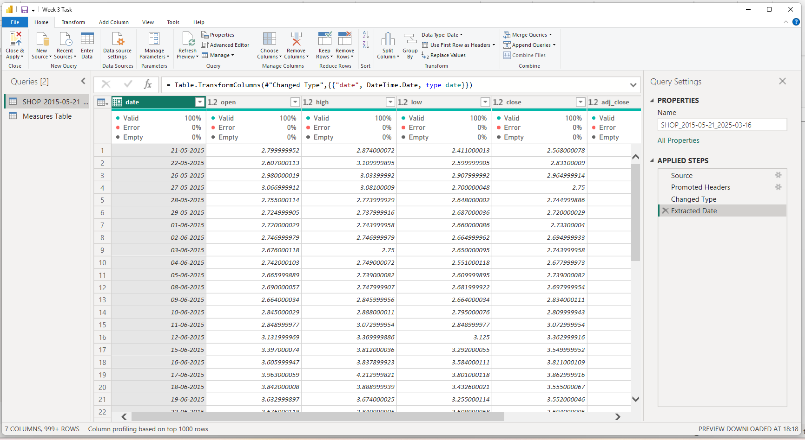

5. Date Table
A dedicated Date Table was created using DAX to support time-based analysis.
The Date Table contains:
• Date
• Year
• Quarter
• Month
• Month Number
• Day
The Date Table provides a structured calendar for performing time-based calculations.

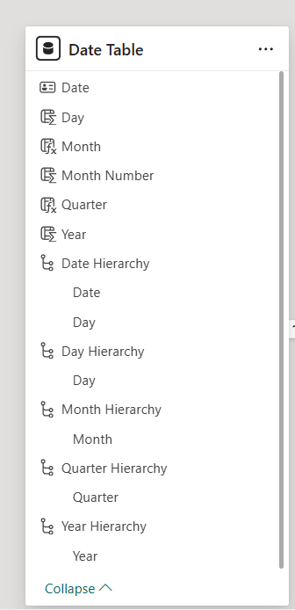

6. Date Hierarchy
A date hierarchy was created to enable drill-down analysis.
Hierarchy
Year → Quarter → Month → Day
This hierarchy allows the stock data to be analyzed at different levels of time, from yearly analysis to daily details.
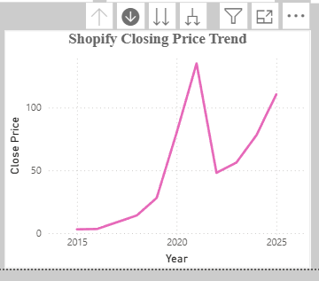

7. Relationship
A relationship was established between the Date Table and the Shopify Stock Data table.
Relationship:
Date Table[Date] → Shopify Stock Data[Date]
Relationship Type:
One-to-Many (1:*)
The Date Table acts as the one-side, while the Shopify Stock Data table acts as the many-side. This relationship allows the Date Table to filter the stock data correctly.

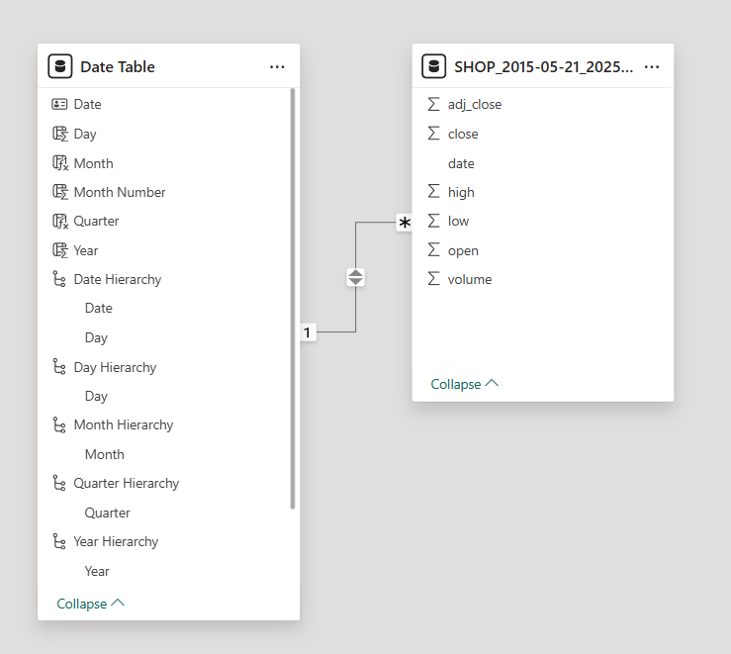

8. DAX Measures
DAX measures were created to calculate important financial metrics.
Measure | Purpose
Open Price | Calculates the opening stock price
Close Price | Calculates the closing stock price
High Price | Identifies the highest stock price
Low Price | Identifies the lowest stock price
Trading Volume | Calculates total trading volume
Previous Close | Retrieves the previous closing price
Daily Return % | Calculates the percentage change in price
Close Price PY | Calculates the previous-year closing price
Close Price YoY % | Calculates year-over-year percentage change
Trading Volume YTD | Calculates year-to-date trading volume
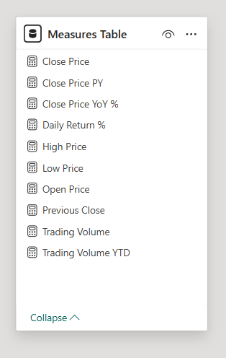
DAX Measures and Time-Intelligence Calculations

9. Time Intelligence
Time Intelligence is used to analyze financial data across different time periods.
In this project, time-intelligence calculations were used to compare stock performance across periods and calculate year-to-date values.
Functions Used
Function | Purpose
DATEADD | Moves the date context to another time period
TOTALYTD | Calculates the value from the beginning of the year up to the selected date
SAMEPERIODLASTYEAR | Compares the selected period with the same period of the previous year
These calculations help in understanding changes in Shopify stock prices and trading activity over time.

10. Dashboard
An interactive Shopify Stock Performance Dashboard was created using Power BI.
KPI Cards
• Open Price
• Close Price
• High Price
• Low Price
• Trading Volume
Slicer
• Date Slicer

Visualizations
• Stock Closing Price Trend – Line Chart
• Monthly Closing Price – Bar/Column Chart
• Trading Volume Trend – Line Chart
The Date Slicer allows users to select a specific date range and interactively filter the dashboard.

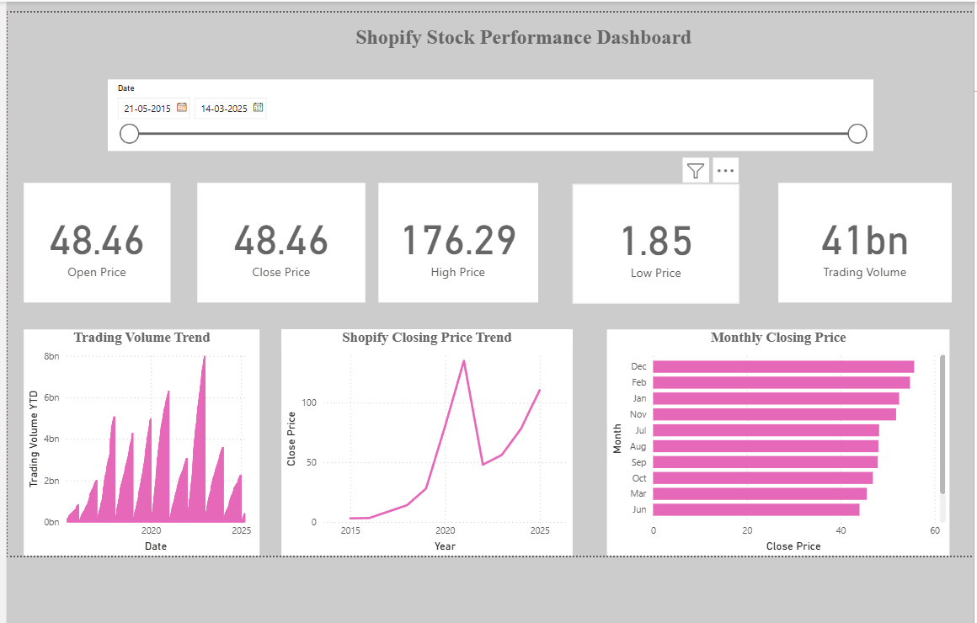

11. Insights
The dashboard provides the following analytical insights:
• KPI cards provide a quick summary of important stock price and trading metrics.
• The closing price trend shows stock price movement over time.
• The monthly closing price chart allows comparison across different months.
• The trading volume trend shows changes in trading activity over time.
• The Date Slicer allows users to analyze a selected time period.
• Time-intelligence measures support comparison between different periods.
12. Conclusion
The Week 3 project successfully demonstrated the process of importing and transforming financial data, creating a Date Table and date hierarchy, establishing data relationships, developing DAX measures and applying time-intelligence calculations using Microsoft Power BI.
An interactive dashboard was created to provide a clear and structured analysis of Shopify stock prices and trading activity over time.

